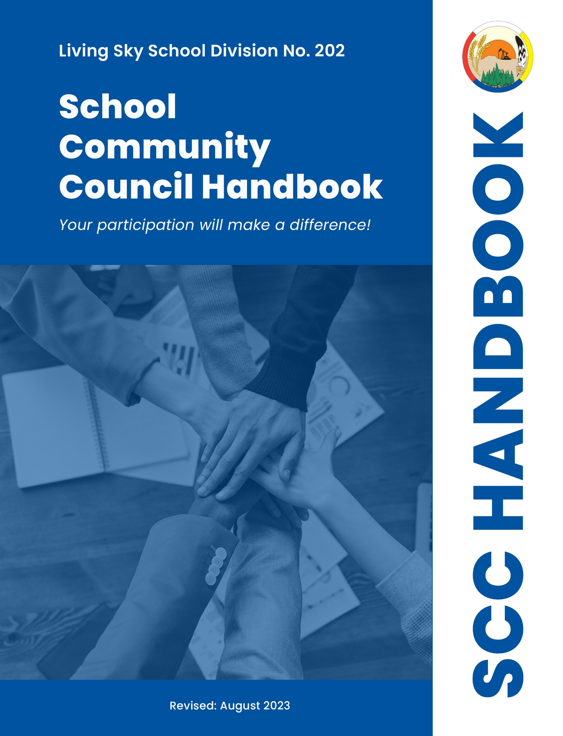

Welcome to your School Community Council (SCC)
We hope this handbook is a useful tool. In it you will find information and ideas that you may select and adapt to meet the needs of your School Community Council.

Mandate
The SCC is comprised of elected members of the school community and appointed staff.

Its mandate is to work collaboratively with the school to develop a school level plan that ensures the learning success and well-being of all students. The SCC encourages and facilitates parent and community engagement in school planning processes to foster engagement between the school and its stakeholders.

As representatives of the school community, SCC members are uniquely positioned to liaise between community and school.

As a result. Learning improvement will be a collaborative effort that encompasses parent, student, and staff voice, in a responsive plan for student success.

Defining Purpose through the Four Pillars
At Living Sky School Division, four mutually supporting pillars underpin our culture, structure, and processes. We strive to be accountable, empowered, connected, and innovative.
School Community Councils help strengthen the capacity of schools to improve children’s learning. SCCs develop shared responsibility for the learning success and well-being of all students and encourage and facilitate parent and community engagement in school planning and improvement processes.

The School Community Council Handbook and Procedure 2.01 demonstrate LSYSD’s commitment to be:
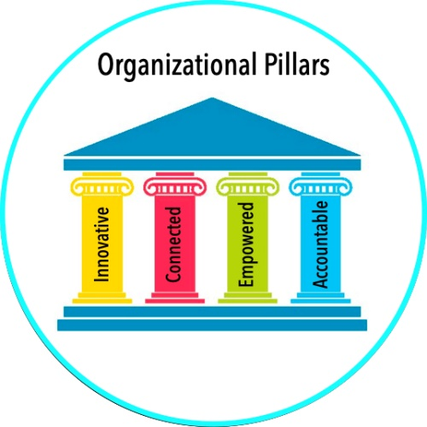
Accountable – Expectations for SCCs are rooted in the Education Act (1995) and The Education Regulations (2019) and are aligned with provincial and division goals.
Empowered – Provision of clear processes and expectations allow SCCs to work collaboratively to support their schools while considering their unique context.
Connected – School improvement thrives when schools and parents are connected and working towards what is best for our kids.
Innovative – With community input, our schools strive to be innovative and make change for the better.
Living our Values
Living Sky School Division’s values should be evident in all that we do. We need to be able to demonstrate:

- Genuine Relationships - Success is built upon strong, authentic relationships with students, families, colleagues and the community. The School Community Council understands the schools and the community’s economic, social and health conditions and needs. The Council strives to facilitate parent and community participation and support in school plans and events. In their activities, School Community Councils engage with schools to ensure all voices are heard and all perspectives are considered. Together, we can overcome challenges and continue along the path toward growth without limits and learning for all!
- Integrity - While considering the needs of our students, school and community, SCCs must comply with the policies of the Division. School Community Councils conduct their affairs in an open and transparent manner. Councils honour the right to privacy of individuals and treat all information they are privy to with appropriate discretion and sensitivity. Councils take advantage of opportunities to build their capacity and account to the public they represent and the Board of Education on their progress.
- Belonging - Participation in School Community Councils should be encouraged and welcomed for all eligible stakeholders. We recognize that all members of a school community can make a difference in the learning success and well-being of children and youth. School Community Councils are viewed as essential members of the team and partners in learning. This inspires a collective effort that results in trusting, committed and long-lasting relationships.
- Innovation – The Council is knowledgeable about resources and supports for the school, parents and community. Councils align their work with provincial and School Division goals. Our SCCs participate in school planning and provide advice regarding policies, programs, facilities, and educational service delivery decisions. Innovation is at the core of these decisions to ensure a quality educational experience for our students.
- Wellbeing - Authentic, positive community involvement in our SCCs results in better outcomes for students. We recognize the freedom and limitations of being but one piece of a larger picture of healthy growth and development for children, young adults and their families. We commit to our piece of excellence and recognize that we are better together.
Constitution:

Each school community council must have a constitution which should be reviewed at the first meeting. This constitution includes:
- Schedule of meetings
- Code of conduct
- Decision making processes
- Means of public communication and consultation; and
- Complaint and dispute resolution processes.

A sample constitution is provided to each school which should be adopted by the SCC. Any changes to the constitution for an SCC can be requested in writing to the Director of Education or designate.

ROLES AND RESPONSIBILITIES
SCC Responsibilities
- In cooperation with the principal and school staff, the SCC will develop and recommend to its board of education for approval, a learning improvement plan that is in accordance with the school division’s strategic plan. The SCC will discuss education-related and school-specific issues both for the current year and for the future of the school and school division.
- Participate in training and development opportunities to enhance capacity to fulfill responsibilities. This might include attending and participating in division-wide activities, information sessions and research projects.
- Not discuss or disclose personal confidential information about or complaints about any pupil, family member or guardian of any pupil, teacher, administrator, or other employee of or member of the board of education.
- Encourage and facilitate parent and community engagement in school planning and improvement processes.
- Account publicly at the Annual General meeting for the expenditure of funds related to the operation of the school community council
- Make recommendations to the Board on subjects relating to school facilities.
- Communicate regularly to parents, guardians and community members about plans, initiatives, and accomplishments.
- Assist in organization and execution of fundraising activities.
- Provide an ongoing organization that will help listen to and communicate the opinions, concerns and proposals of community members and parents/guardians.
- Create opportunities for parents/guardians and community members to become involved in the activities and life of the school.

Board Responsibilities:
- Provide ongoing orientation, training, development and networking for School Community Councils.
- Designate a School Division contact with the Senior Administration

Principal and Teacher Responsibilities:
- The Principal shall bring forward the annual School Learning Improvement Plan for review.
- Provide an open and inviting school climate
- Provide information to support SCC decision making
- Should NOT serve as chairperson, vice chairperson, or secretary

OPERATIONS

Meetings
Each School Community Council must meet at least 5 times in a school year and hold an Annual Meeting. Please note that minutes of each School Community Council meeting will be kept and a copy of the minutes should be saved in the school’s “shared files” Teams folder.

Annual General Meeting and Elections
School Community Council Elections must be held at the same time as the SCC’s Annual General Meeting. The AGM and Elections must be held before the end of October every year. It is advised that the AGM date be set by the end of May each year. The School Community Council AGM and Elections must be publicly noted at least 4 weeks in advance. This could happen via school newsletter, school website or notes sent home. Community members may submit their names for election for the following positions: Chairperson, Vice-Chairperson, and Secretary. All positions run for a 2-year term so an election for each position may not be needed in October. If an election is required, the school must appoint a Returning Officer to count ballots. This returning officer must not be a member of the SCC (could be school secretary, another school employee etc.)

Communication
In order to facilitate communication with the Board, The Director or Education or designate will plan and facilitate a Board/SCC Forum. The Forum will be hosted annually with the following purpose:
  - Share information related to goals and priorities
  - Share information related to the Board of Education Strategic Plan
  - Dialogue related to matters of interest.

Principals shall initiate activities at the school level designed to promote communication between the school, the home, and the community. Some methods the principal may use to promote communication are:
- Opportunities to volunteer when appropriate
- School newsletters (digital or paper)
- School websites or social media platforms
- Teacher notes
- Student-Led Conferences
- Open houses / Meet the staff events
- Family events

MANAGING FUNDS
School Community Council Grant
The Board of Education for Living Sky School Division is ultimately responsible for all funds utilized in the delivery of services within the School Division, including those funds that are school based.
The School Community Council is responsible to the Board of Education for ensuring that the school-based funds allocated to the SCC are accounted for. In the administration of a trust, School Community Councils shall exercise diligence and care in the management of these funds.

The Board of Education annually establishes a grant, which provides operations funds for School Community Councils. This amount cannot be carried over from one year to the next. Funds are allocated for Council operations only, not for school projects or to enhance the school’s decentralized budget. All monies spent will be tracked through school accounting processes and should be presented annually at the AGM. All monies generated by fundraising through the SCC will be managed through the school funds accounting process.

Examples of appropriate use of the School Community Council Grant:
- Vehicle expense allowance for members to travel to regular meetings
- Vehicle expense allowance for out-of-community meetings or events
- Communication and public relations
- Memberships in provincial organizations
- Conference attendance and professional development
- Incidental expenses such as postage and printing, refreshments for meetings and other costs incurred by the School Community Council to carry out its operating activities (e.g. childcare expenses)
- Expenses do not include per diems or honorariums for council members as School Community Council members are not eligible for compensation for their role on the School Community Council.

Payment of School Community Council Expenses:
Operating expenses of the School Community Council may be paid through regular school processes. Travelling expenses will be paid by submitting a General Travel Expense Claim for an SCC member.

Fundraising Activities:
All fundraising activities in which a School Community Council is involved are to be coordinated with the school. The established processes and accounts in place to manage the school’s other school-based funds and fundraising activities will similarly be used for the fundraising activities of the School Community Council.

